**CRITTER CHRONOLOGER PROJECT DOCUMENTATION**

**Step-by-Step Roadmap with screenshots:**

**PHASE 1: DATABASE CONFIGURATION**

**Step 1.1: Create MySQL Database**

* Create a database called critter in MySQL

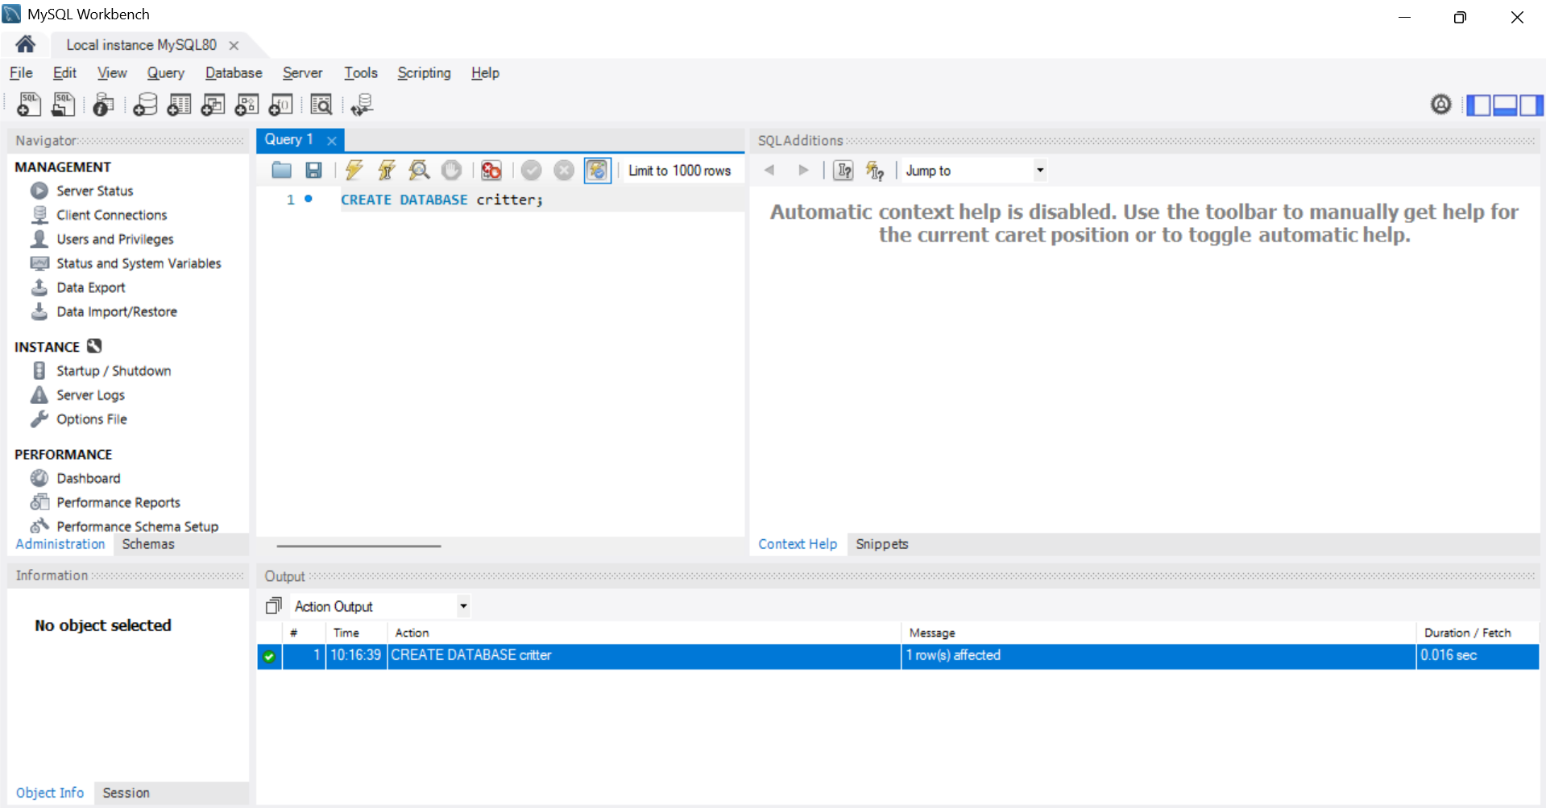

**Step 1.2: Configure application.properties (Main)**

* Configure connection to MySQL database

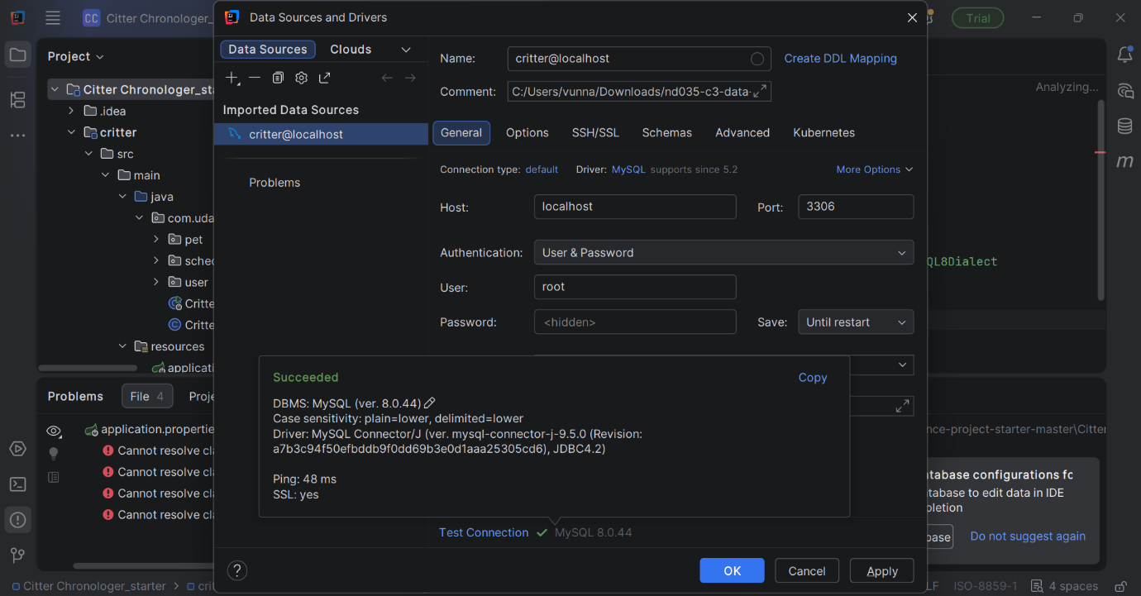

* Set up Hibernate auto-generation

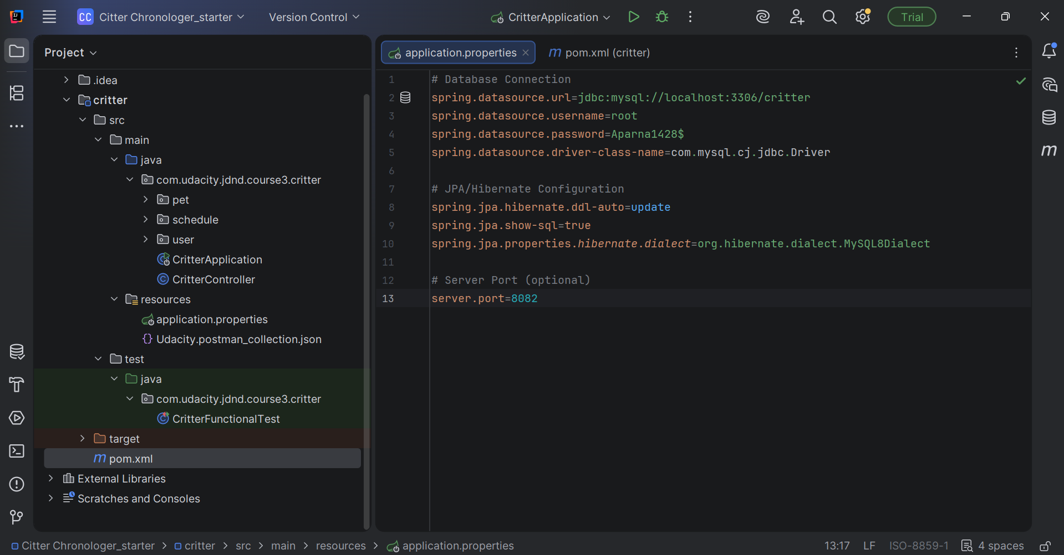

**Step 1.3: Configure application.properties (Test)**

* Configure H2 in-memory database for tests

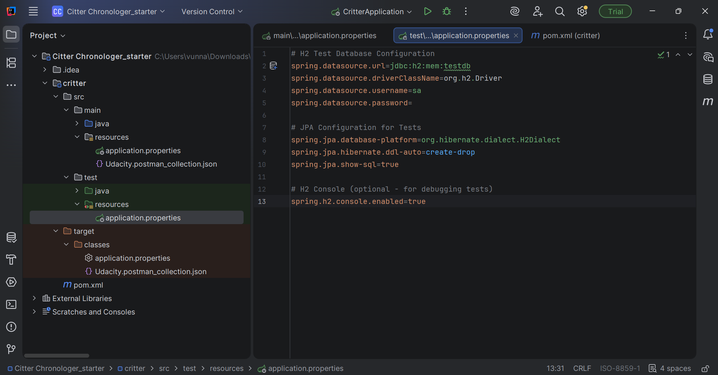

**PHASE 2: DESIGN DATA MODEL (ENTITIES)**

**Step 2.1: Understand the Data Structure**

* Customer (owner of pets)
* Pet (belongs to customer)
* Employee (provides services)
* Schedule (links employees + pets + activities + date)

**Customer (Pet Owner)**

* Has: name, phone number
* Relationship: Can own multiple pets (one-to-many)

**Pet (Animal)**

* Has: name, type (dog/cat/etc), birth date
* Relationship: Belongs to ONE customer (many-to-one)

**Employee (Service Provider)**

* Has: name, skills (walking, feeding, etc), available days
* Relationship: Can work on multiple schedules

**Schedule (Appointment)**

* Has: date, activities (what services)
* Relationship: Links multiple employees + multiple pets (many-to-many)

**Step 2.2: Create Customer Entity**

* Create Customer.java entity class

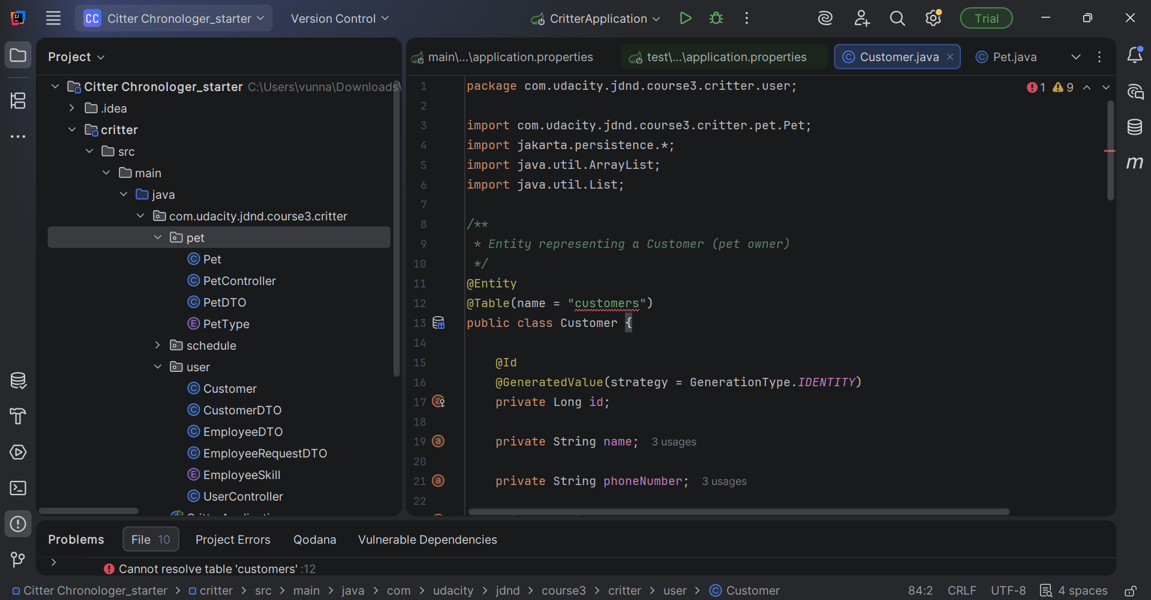

**Step 2.3: Create Pet Entity**

* Create Pet.java entity class
* Link to Customer (Many-to-One relationship)

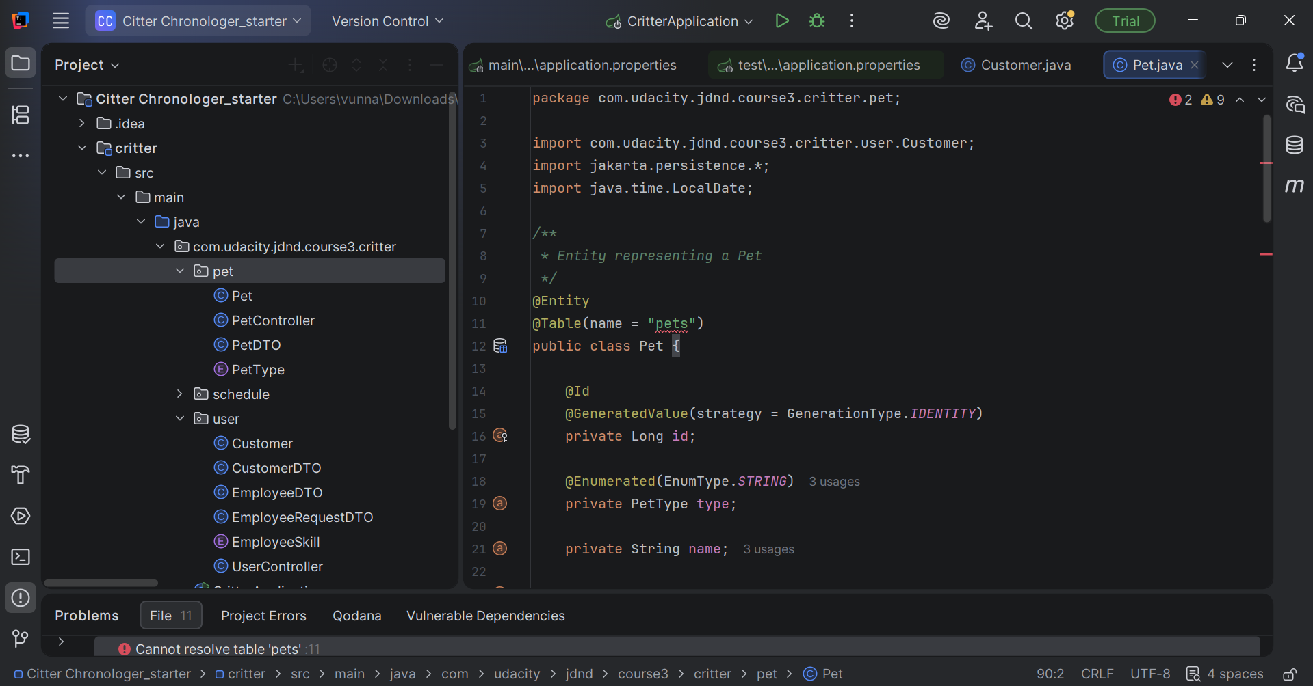

**Step 2.4: Create Employee Entity**

* Create Employee.java entity class

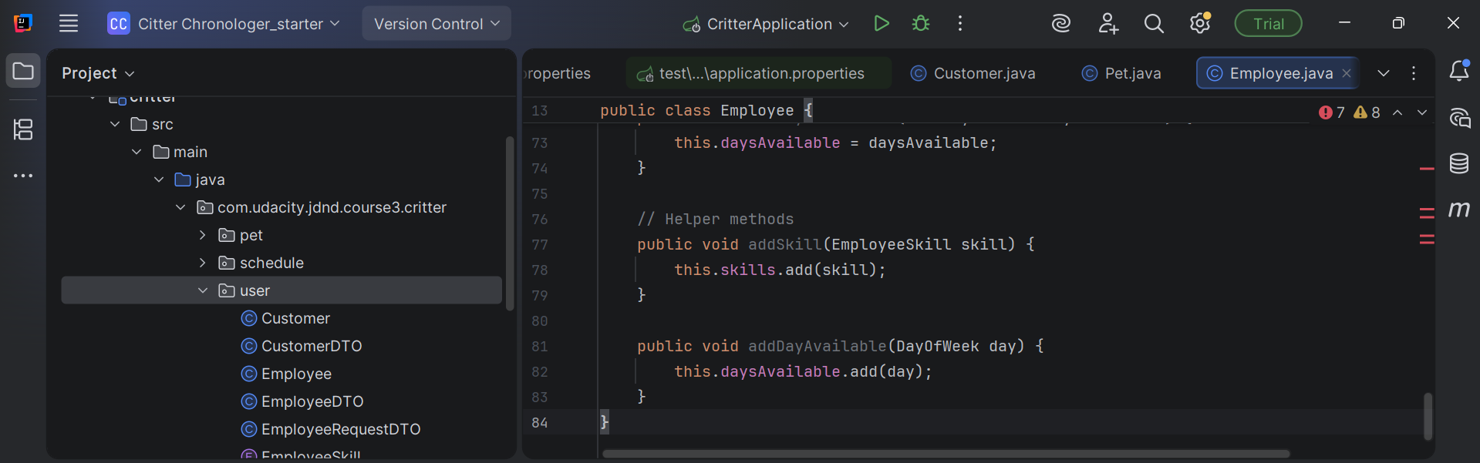

**Step 2.5: Create Schedule Entity**

* Create Schedule.java entity class
* Link to Employees (Many-to-Many)
* Link to Pets (Many-to-Many)

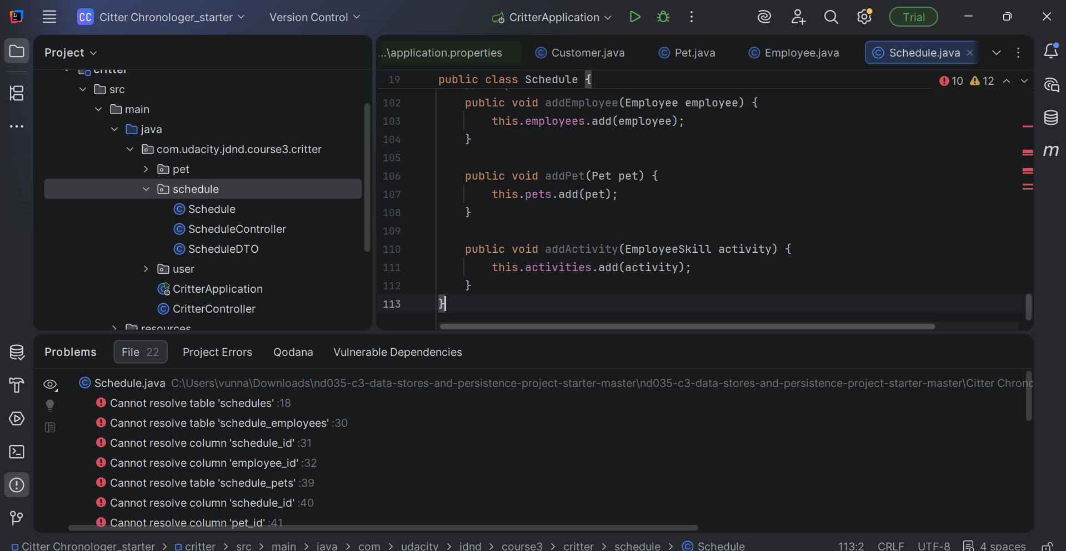

Errors exist because the database does not exist yet.

**PHASE 3: CREATE DATA ACCESS LAYER (REPOSITORIES)**

**Step 3.1: Create Customer Repository**

* Create CustomerRepository.java interface

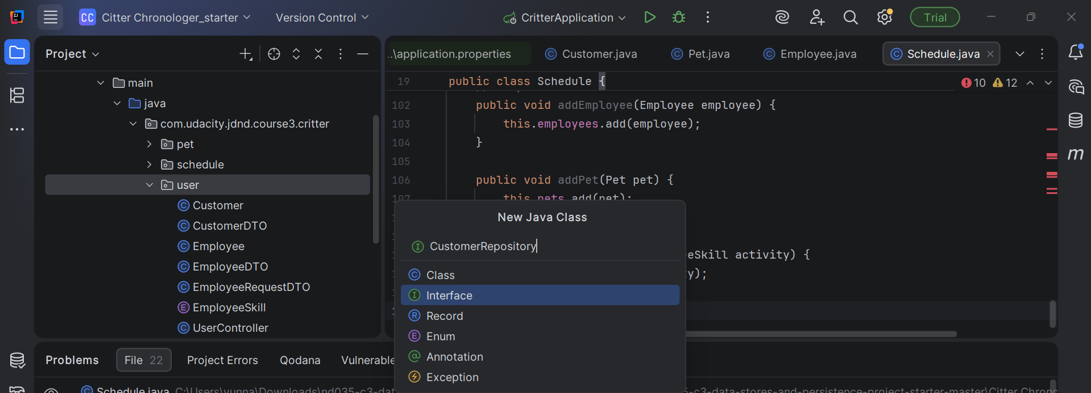

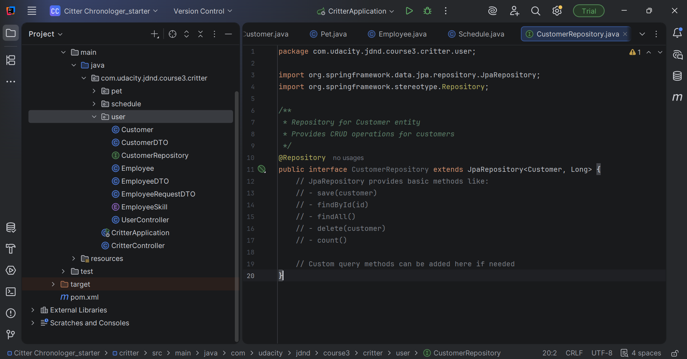

**Step 3.2: Create Pet Repository**

* Create PetRepository.java interface

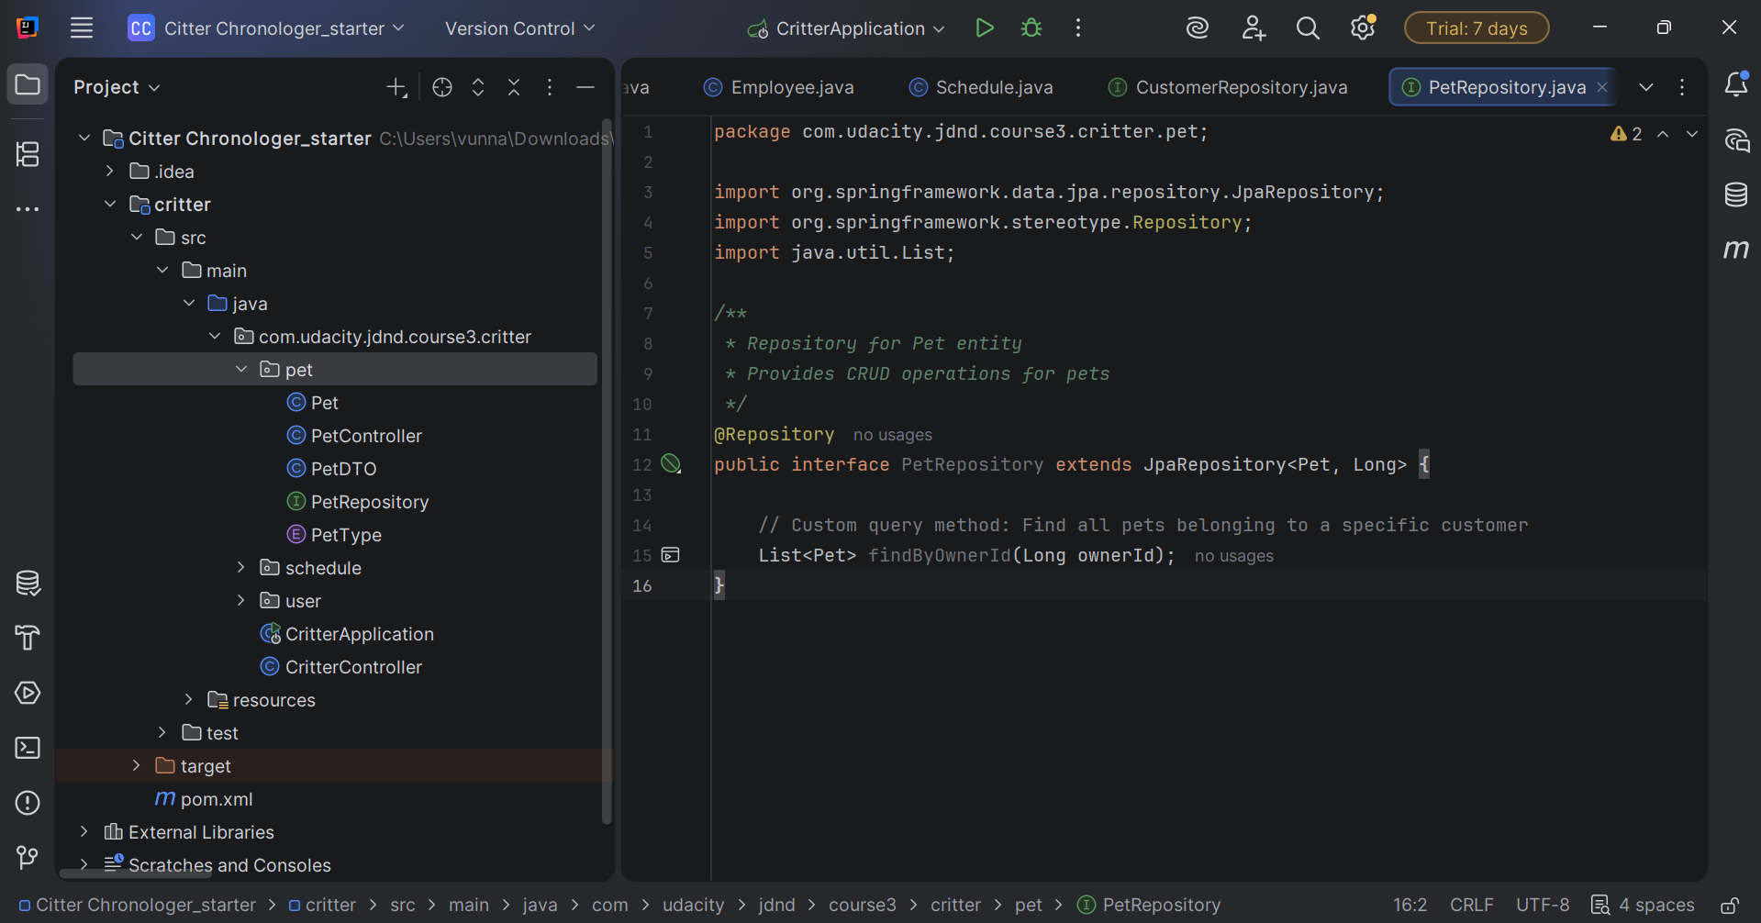

**Step 3.3: Create Employee Repository**

* Create EmployeeRepository.java interface

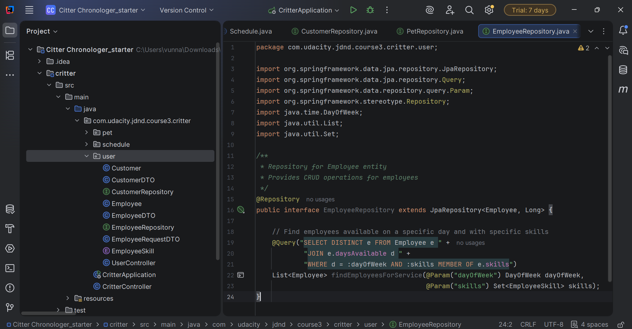

**Step 3.4: Create Schedule Repository**

* Create ScheduleRepository.java interface

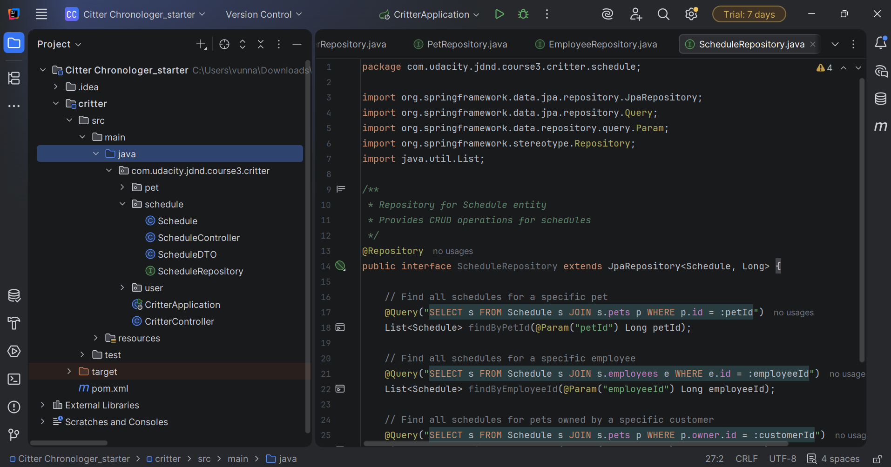

**PHASE 4: CREATE SERVICE LAYER**

**Step 4.1: Create Customer Service**

* Create CustomerService.java class
* Implement business logic for customers

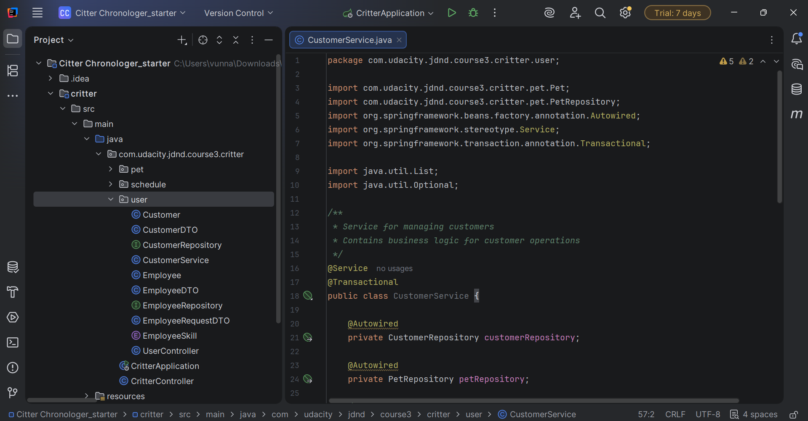

**Step 4.2: Create Pet Service**

* Create PetService.java class
* Implement business logic for pets

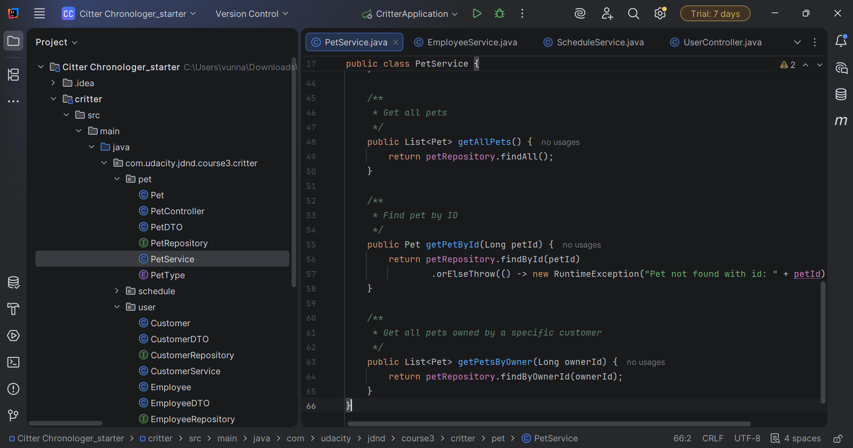

**Step 4.3: Create Employee Service**

* Create EmployeeService.java class
* Implement business logic for employees

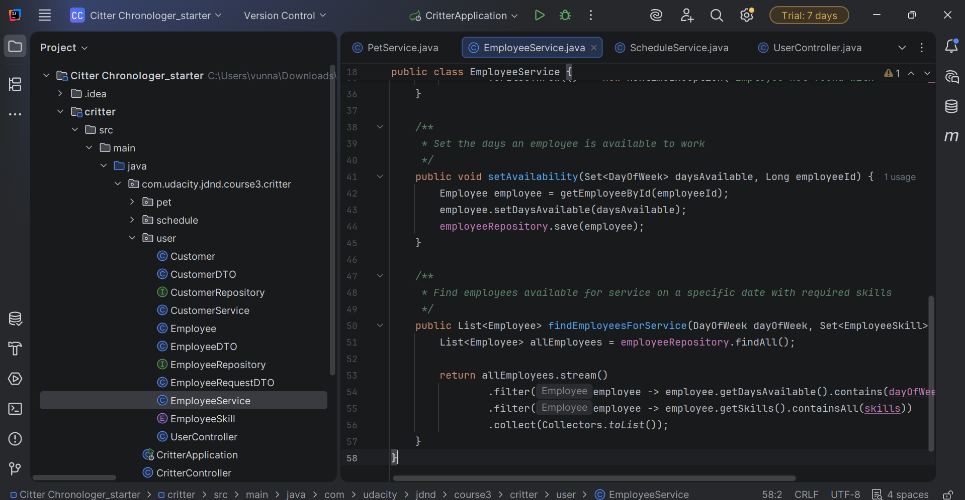

**Step 4.4: Create Schedule Service**

* Create ScheduleService.java class
* Implement business logic for schedules

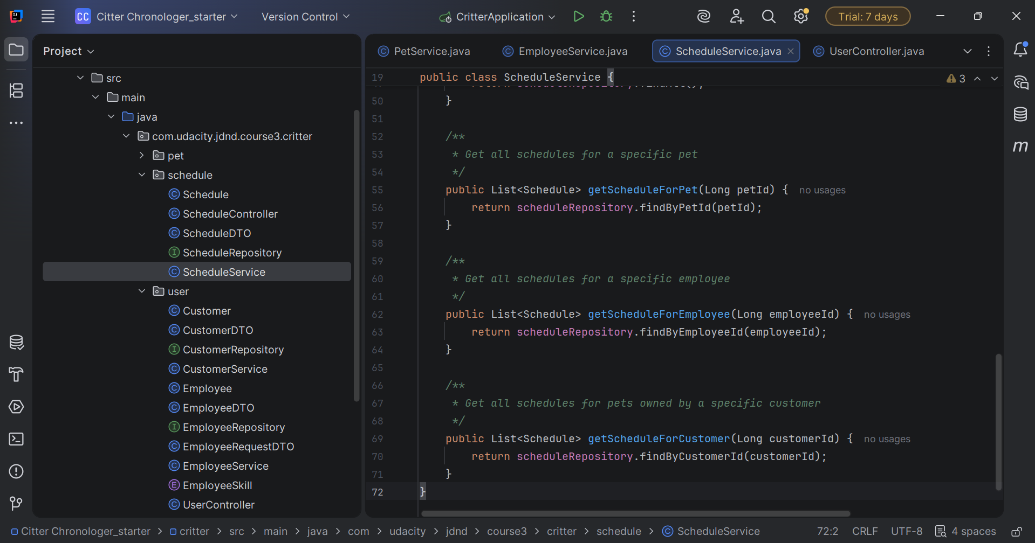

**PHASE 5: COMPLETE CONTROLLERS**

**Step 5.1: Complete UserController**

* Implement saveCustomer()
* Implement getAllCustomers()
* Implement getOwnerByPet()

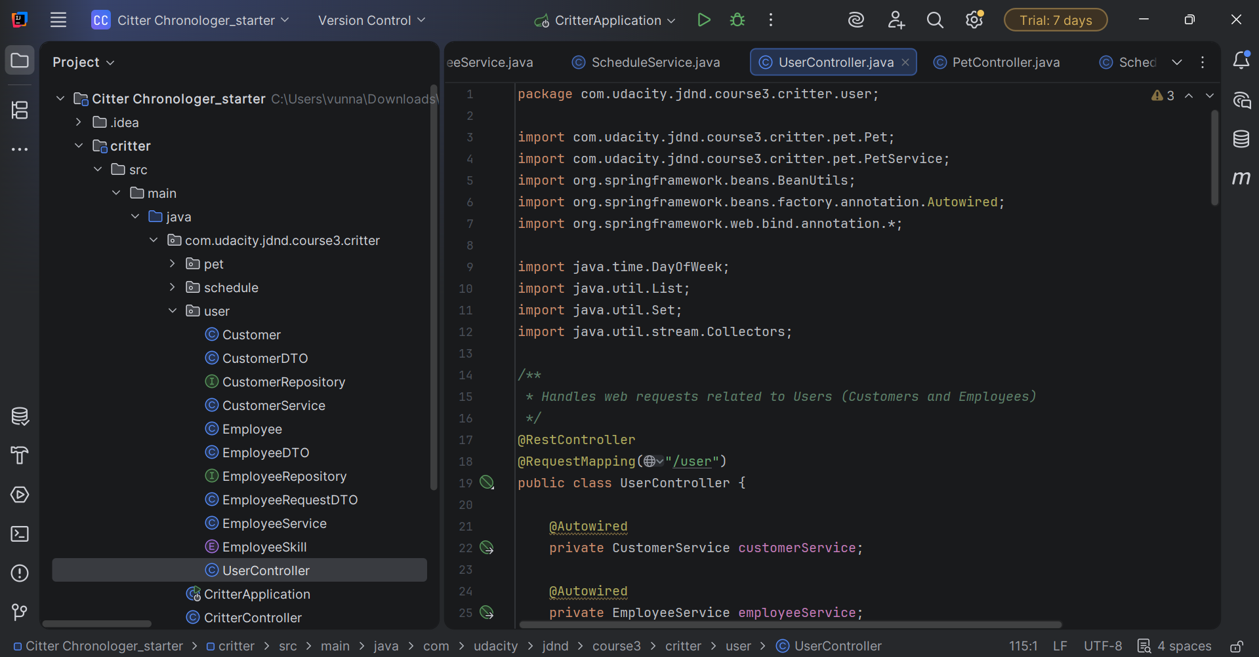

**Step 5.2: Complete PetController**

* Implement savePet()
* Implement getPets()
* Implement getPetsByOwner()

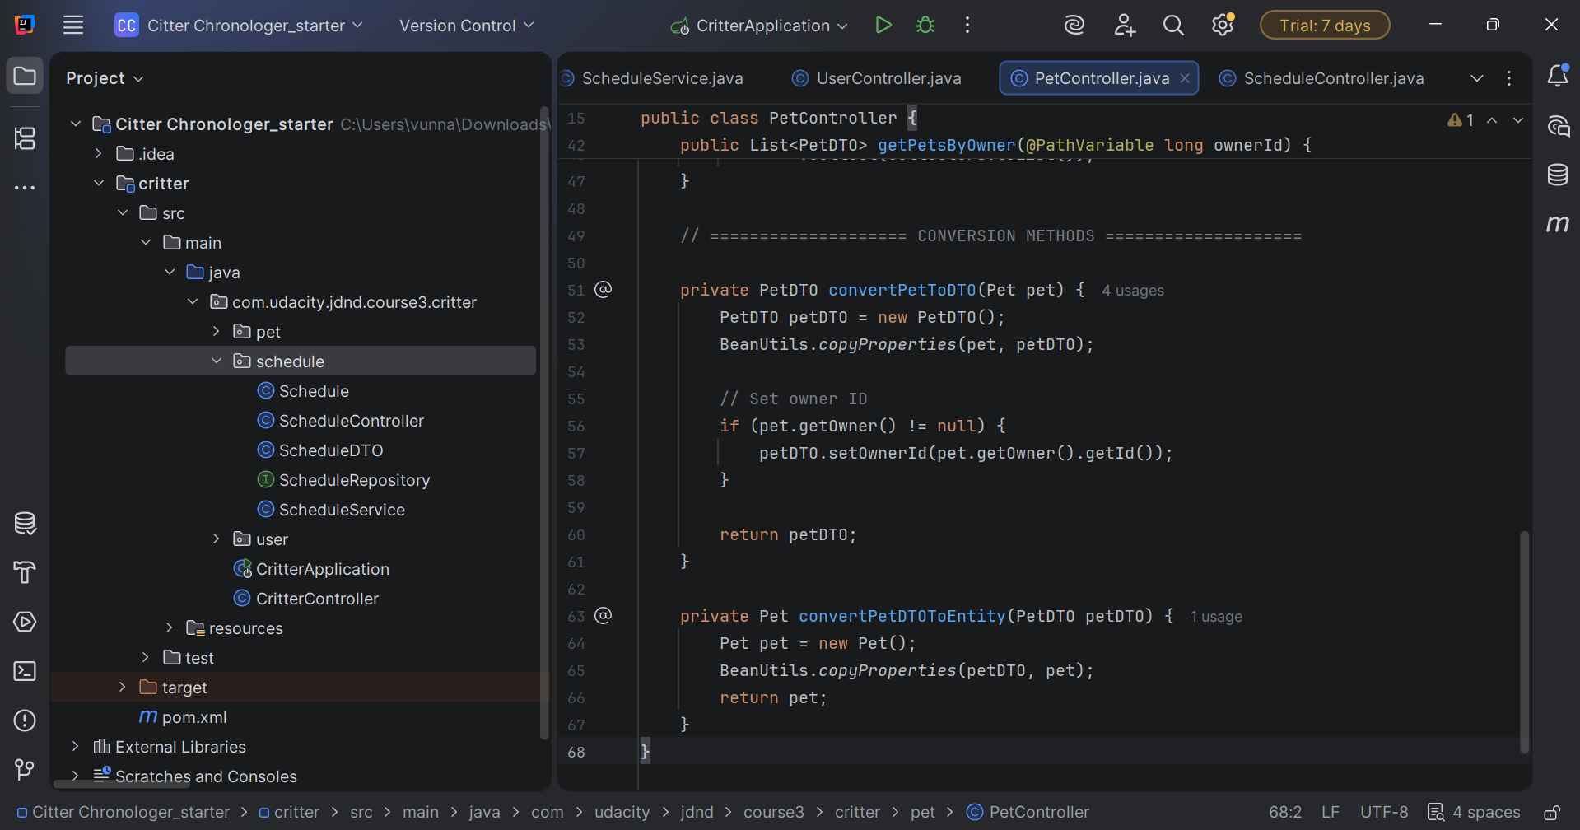

**Step 5.3: Complete ScheduleController**

* Implement createSchedule()
* Implement getAllSchedules()
* Implement getScheduleForPet()
* Implement getScheduleForEmployee()
* Implement getScheduleForCustomer()

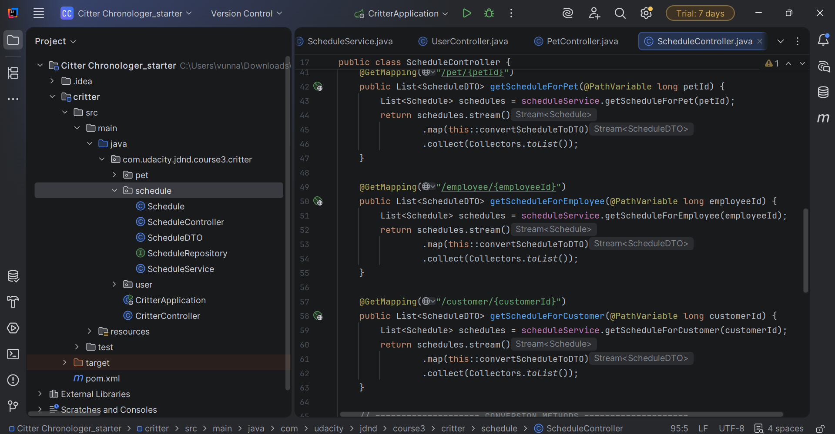

**PHASE 6: TESTING & DEBUGGING**

**Step 6.1: Run Unit Tests**

* Run the provided JUnit tests
* Fix any failing tests

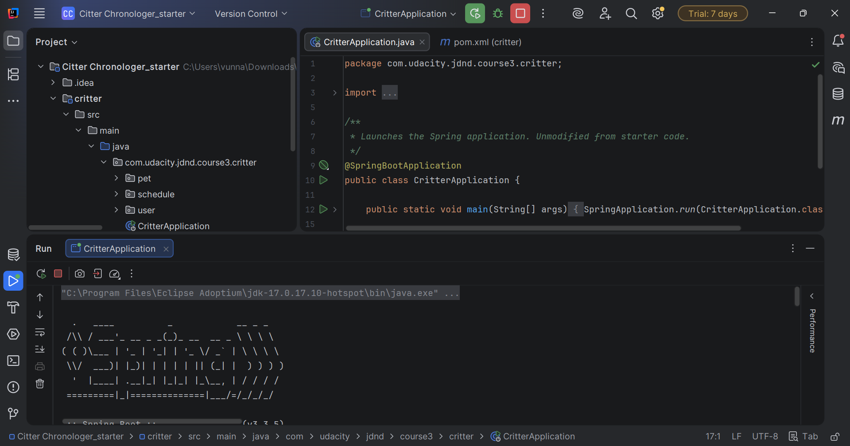

**Step 6.2: Test with Postman**

* Import the Postman collection

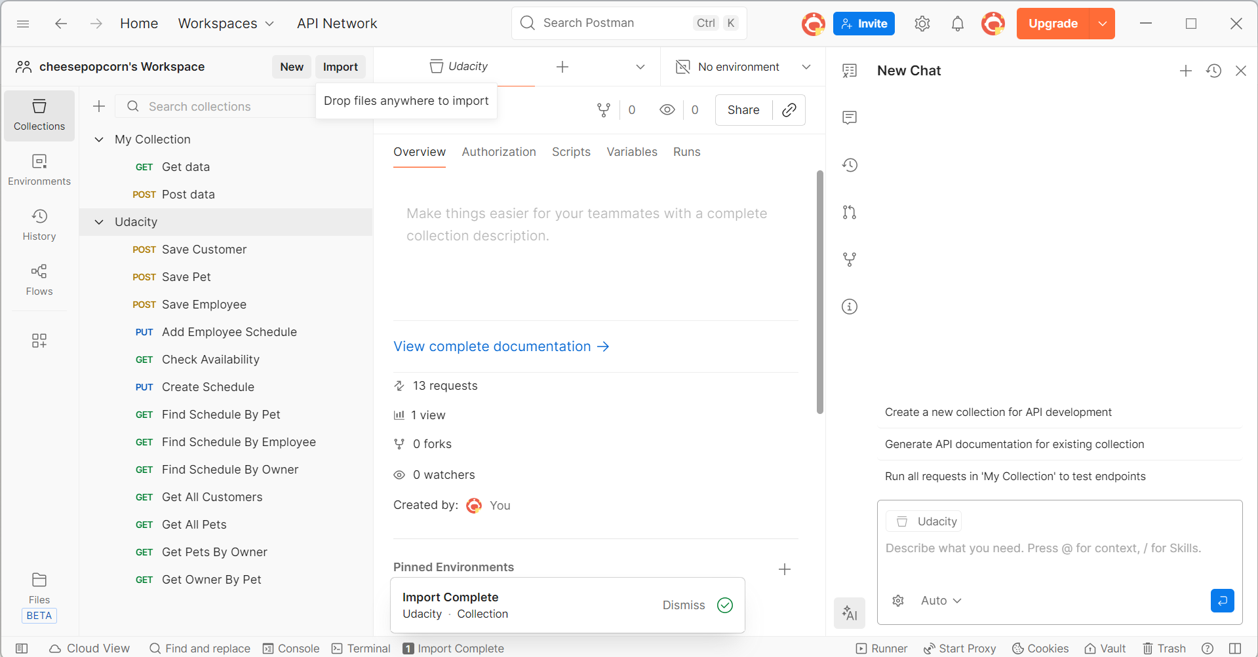

* Test each endpoint manually

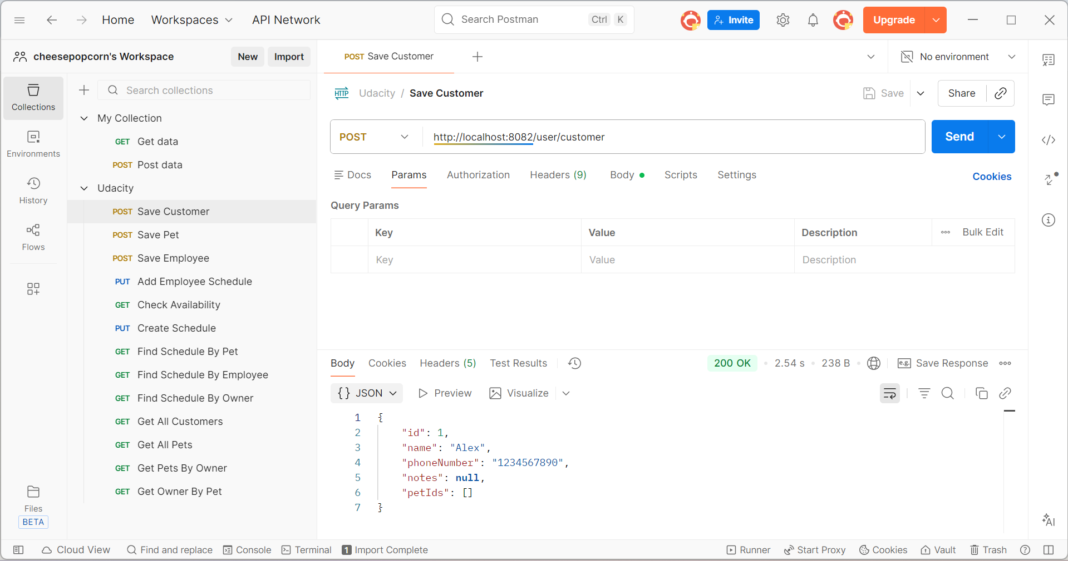

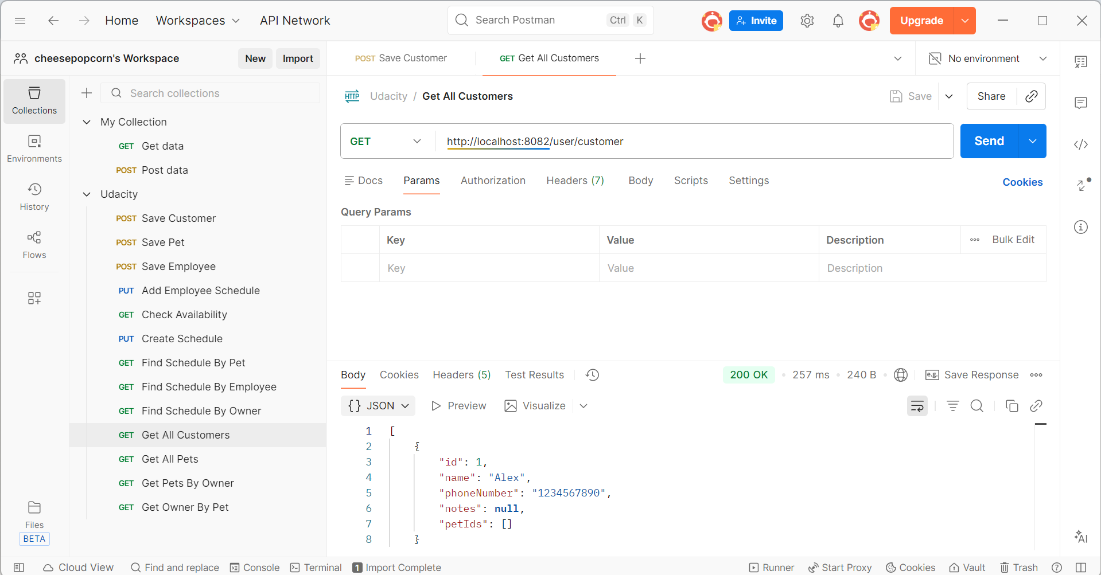

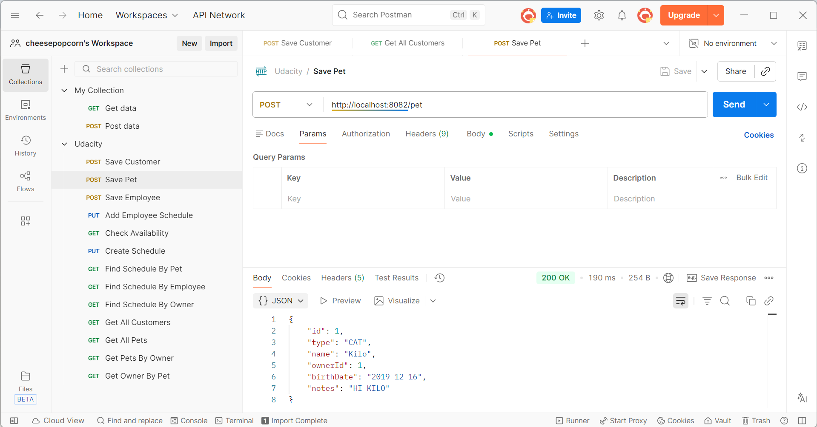

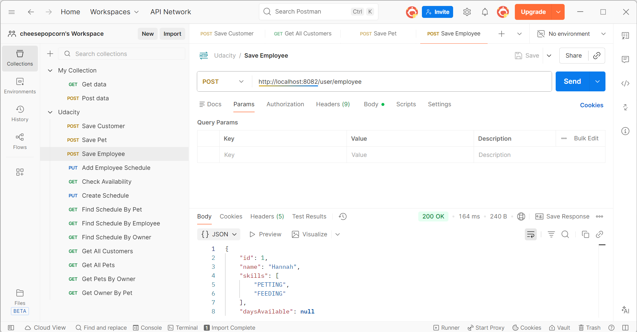

**Step 6.3: Verify Database**

* Check tables in MySQL Workbench

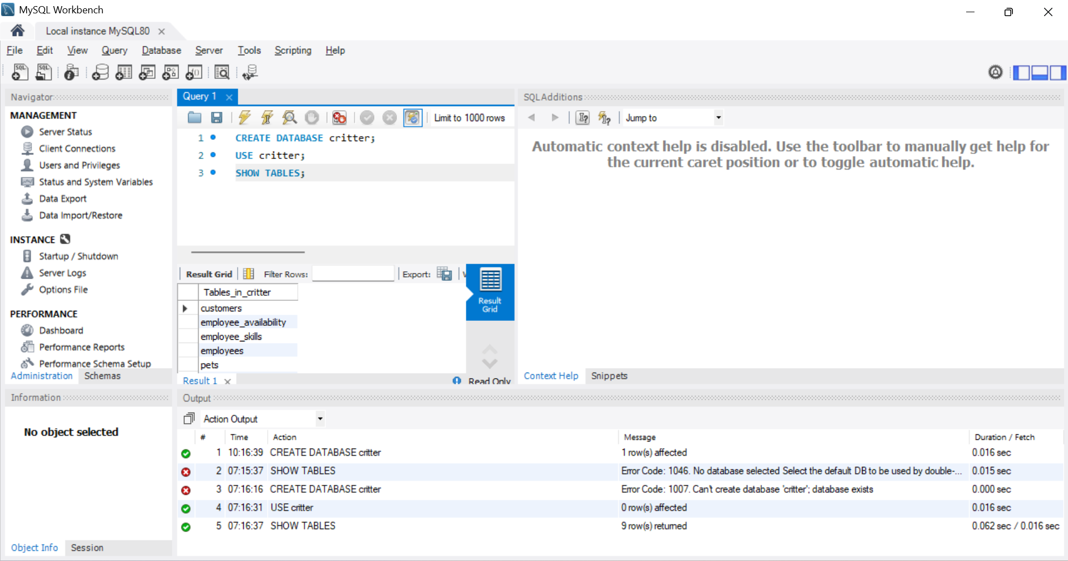

* Verify data is being saved correctly

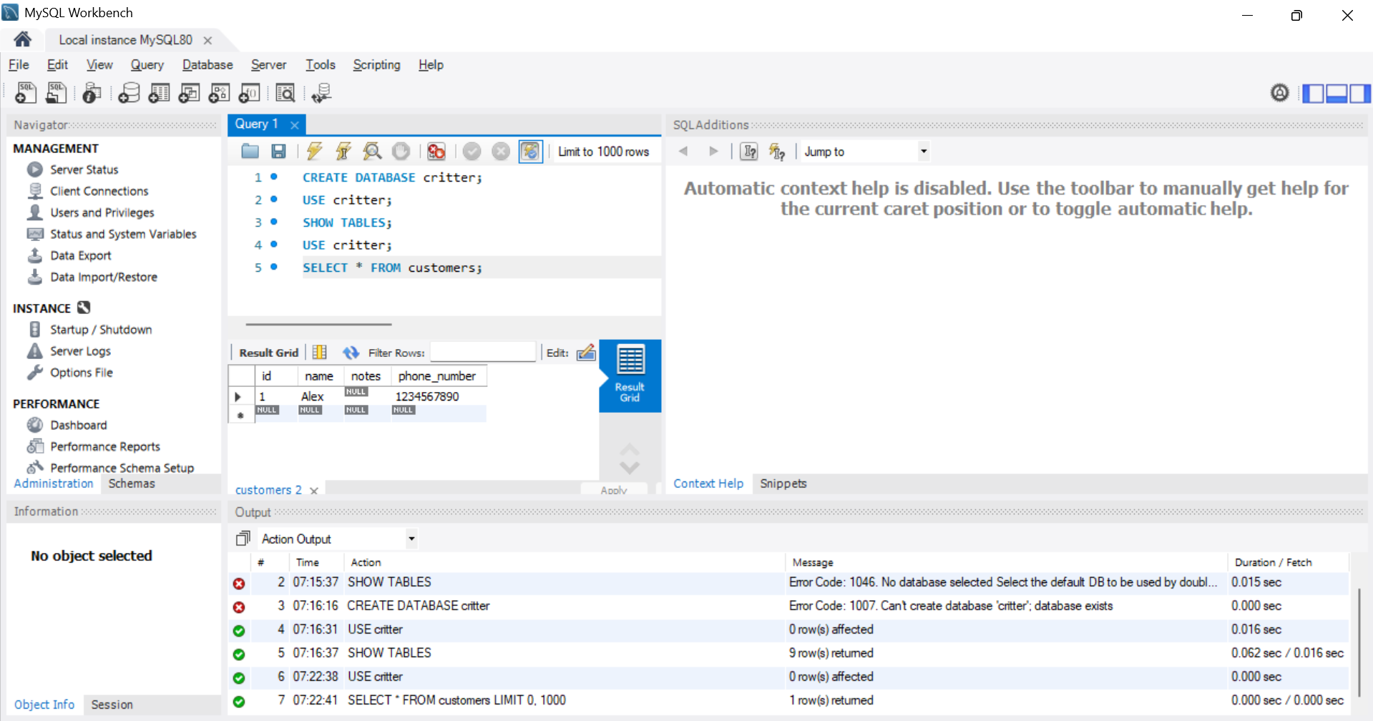

* All unit tests pass

